ISSN: 2579-079X

©IDOSR PUBLICATIONS

International Digital Organization for Scientific Research IDOSR JST/25/1120000
IDOSR JOURNAL OF SCIENCE AND TECHNOLOGY 11(2):10-20, 2025.
https://doi.org/10.59298/IDOSR/JST/25/112.102000

Bioaccumulation of Heavy Metals in Artisanal Miners and Associated Health Risk Assessment in Michika Local Government Area, Adamawa State, Nigeria

Maitera O. N., Yusuf E.Y., Buba One M. and Joshua G. A.

Corresponding mail: emmanuelyila@gmail.com
¹Modibbo Adama University Yola, ²University of Agriculture Makurdi, ³Borno State University, ⁴Gombe State University.

ABSTRACT
Artisanal and small-scale mining (ASM) is a widespread economic activity in Michika Local Government Area (LGA), Adamawa State, Nigeria. Despite its economic value, ASM poses significant environmental and public health challenges due to heavy metal contamination. This study assessed the levels of bioaccumulated heavy metals specifically lead (Pb), cobalt (Co), chromium (Cr), arsenic (As), iron (Fe), manganese (Mn), zinc (Zn), and copper (Cu) in soil, water, and blood samples from mining locations. The analysis was carried out using atomic absorption spectrophotometry (AAS) Model: AA320N. High concentrations of Pb (2.89 ppm), Co (0.16 ppm), and Cr (0.34 ppm) in soil were found to exceed World Health Organization (WHO) limits, while heavy metals like Fe,Co and Pb in water where higher in some locations like Garta, Sina mala.. Blood analysis of artisanal miners revealed significant bioaccumulation, particularly for Pb (mean: 25.94 µg/L), As (12.54 µg/L), and Mn (14.36 µg/L), with several values exceeding WHO safety thresholds. Bioaccumulation factors (BAF) and correlation analysis confirmed water as a major exposure pathway. Health risk assessments indicated high hazard quotients (HQ > 1) and unacceptable cancer risks (CR > 1.0×10⁻⁴) in mining communities such as Garta, Garta Sama and Sina Mala. These findings reveal the urgent need for environmental remediation, strict regulation of ASM practices, and health monitoring programs for affected populations in Michika LGA.
Keywords: ASM, Heavy metal, Bioaccumulation, WHO, Hazard quotient and Cancer risk

1. INTRODUCTION
Mining involves extracting valuable minerals and geological materials from the earth, but it is inherently destructive, often causing significant environmental harm. While regulations exist to mitigate these impacts, they are frequently insufficient, particularly in regions where enforcement is weak, making it difficult for mining activities and wildlife to coexist harmoniously [1]. Nigeria is endowed with abundant solid minerals, including precious stones, metals like gold and tin, and industrial minerals such as limestone, coal, and marble [2]. These resources, scattered across the country, attract both formal and informal mining activities, though they remain largely untapped on a large scale. The estimated market value of Nigeria's solid mineral deposits is in the hundreds of trillions of dollars, highlighting their economic potential [3]. Artisanal and small-scale mining (ASM) is prevalent in many parts of Nigeria, especially in regions rich in mineral resources. In Michika LGA, Adamawa State, ASM serves as a major livelihood for a significant segment of the population. Unfortunately, the unregulated nature of these mining activities leads to widespread environmental degradation and increased human exposure to toxic substances, particularly heavy metals. Heavy metals such as lead (Pb), cadmium (Cd), arsenic (As), chromium (Cr), and mercury (Hg) are commonly associated with mining and have been linked to numerous health problems including neurological disorders, kidney damage, cancer, and developmental issues in children [4]. The bioaccumulation of these metals in miners through inhalation of dust, ingestion of contaminated water or food, and dermal contact represents a serious health hazard [5]. This study focuses on evaluating the levels of heavy metals in environmental sites (soil and water) and biological samples (blood) from artisanal mining communities in Michika LGA. The goal is to assess the extent of exposure and conduct a health risk assessment based on standard indices recommended by USEPA.

Materials and Methods
Study Area
Michika LGA is located in the northern part of Adamawa State, Nigeria. It lies within the coordinates 10°39’N and 13°23’E, characterized by a tropical savanna climate with distinct wet and dry seasons. Mining activities in the region include extraction of gold, Uranium, and lead, predominantly through manual labor.
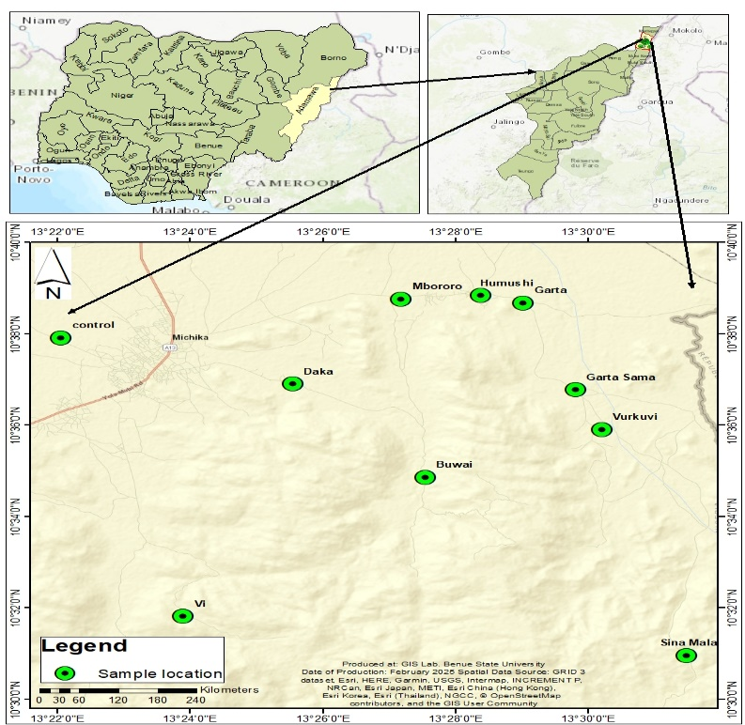
Figure 1: Map of Adamawa state showing Sampling point
Sample Location and Site Description
Soil, blood and water samples was collected from the Michika local government area of Adamawa state Nigeria. The coordinates of Michika are 10°37’N, 13°23’E, respectively. Adamawa state is a settlement located in North east of Nigeria. The area falls within the Basement Complex of the Northeastern Nigeria and covers an aerial extent of about 188.5 km. It lies within latitudes 100 32’N to 100 14’N and longitudes 130 19’ E to 130 25’E.
Sample collection
Soil and Water Samples were collected from ten mining sites (active and abandoned site) and this include (Vi, Garta, Garta Sama, Sina Mala, Mbororo, Buwai, Vurkuvi, Daka and Humushi) and a control site 1 km away from mining activity. A total number of twenty (20) soil sample and twenty (20) water sample were collected. The immediate source of water within the mining exploration was used. The sources include the effluents pumped by the miner for the purpose of washing/separation of the mineral and also from any channels leading away from the exploration processes. The water from the control site was directly collected from a dam meters away from the mining area. The composite samples of water were collected in prerinsed plastic containers and mixed to make representative samples.
Blood samples were collected from 5 artisanal miners (from random sites), aged 25– 40 years, who had been engaged in mining for over a year. All subjects were informed of the objective of the study and their consent was obtained. Ethical clearance from ethical committee of the state ministry of health was obtained before blood collection. Blood samples were collected in the morning around 9 am from five volunteers, as many were not willing due to illegality of the mining activities. 5 ml of blood samples were collected through venipuncture. Samples were collected in a royal blue EDTA tube. The collection of the blood was conducted by health worker. Blood was collected by venipuncture using a phlebotomy needle. EDTA tube was inverted about 8–10 times to prevent clotting. Each specimen tube was attached with an identification label. Specimens were stored at 4 ⁰C ice block before talking to the laboratory.
Sample Pretreatment and Preparation
Soil samples was pretreated through washing, drying and in some cases grinding to size particles of 2 mm to distinguish between small and large particles. The goal of pretreating the samples is to prepare the test sample in which the concentration of the contaminant is equal to the concentration in the original soil provided. However, this procedure may not alter chemical specie analyzed.

Digestion of Water Sample
The EPA vigorous digestion method described by [6], was adopted. 100 ml of each of the representative water samples was transferred into Pyres beakers containing 10 ml of concentrated HNO₃. The samples were boiled slowly and then evaporated on a hot plate to the lowest possible volume (about 20 ml). The beakers were allowed to cool and another 5 ml of Conc. HNO₃ was added. Heating was continued with the addition of Conc. HNO₃ as necessary until digestion is complete. The samples were evaporated again to dryness (but not baked) and the beakers were cooled, followed by the addition of 5ml of HCl solution (1:1 v/v). The solutions were then warmed and 5ml of 5 M NaOH was added, then filtered. The filtrates were transferred to 100 ml volumetric flasks and diluted to the mark with distilled water. These solutions were hence be used for the elemental analysis.
Laboratory Analysis
All samples were digested using nitric-perchloric acid mixtures and analyzed for heavy metal concentration, using Atomic Absorption Spectrophotometry (AAS). Calibration standards and blanks were run to ensure accuracy and precision.
RESULTS AND DISCUSSION

Figure 2: The mean concentration of heavy metal in water sample from Mining Site
Figure 2 shows the mean concentrations of heavy metals (Zn, Cr, Pb, Cu, Co, Fe) in water sample from artisanal mining site. The mean concentration of heavy metals at different locations ranges from 0.812±0.05 to 7.172±0.19 Zn; 0.002±0.0 to 0.156±0.01 Cr; 0.001±0.0 to 0.021±0.0014 Pb; 0.06±0.001 to 1.236±0.089 Cu; 1.625±0.0143 to 50.572±3.25 Fe; and 0.001±0.0 to 0.581±0.04 Co;
From figure 2, the highest concentration of iron was 50.198 ppm and was observed in Vi while the lowest concentration was observed in Daka (1.625 ppm), highest concentration of zinc was 0.812 ppm and was observed in Daka while the lowest concentration was observed in Buwai (7.172ppm), highest concentration of chromium was 0.156 ppm and was observed in Garta while the lowest concentration was observed in Buwai (0.02ppm), the highest concentration of copper was 1.236 ppm and was observed in Garta while the lowest concentration was observed in control (0.006ppm), the highest concentration of cobalt was 0.581 ppm and was observed in Sina Mala while the lowest concentration was observed in control (0.001ppm). The highest concentration of lead was 0.021 ppm was observed in Garta while the lowest concentration was observed in Garta Sama (0.001ppm),
From the result, concentration of Fe, in all the location are higher than WHO standard limits of 0.3 ppm. The concentration of Zn is within the WHO standard limit of 3 ppm. Meanwhile zinc is an essential trace element necessary for human health, elevated levels in drinking water can lead to undesirable effects. However, the WHO notes that zinc concentrations above 3 mg/L (3 ppm) can impart an undesirable taste to water and may cause it to appear opalescent with a greasy film upon boiling, with levels reaching up to 7.171 ppm. While this may not pose significant health risks, it can affect the water's taste and appearance, potentially making it less palatable. However, locations like Garta, Garta Sama and Sina Mala where above the WHO standard for chromium in water. A study done to determine the levels of heavy metals in the Tigris region of Northern Ethiopia recorded the following mean levels; Alamata 0.317 mg/l, Mekelle 0.646 mg/l, Wekro 0.616 mg/l [7]. These levels were higher than the levels recorded in this study. More again Cu was also within the WHO standard limits, except for Garta, which was above 1 ppm. The concentrations of Cu in Garta were higher than those reported in those of South Africa [8], Ghana [9], Abakaliki [10], and Anka [11], respectively Cobalt value in Garta, Daka and Sina Mala where Above WHO Standard limits. Pb also in locations Like Garta, Daka and Sina Mala were slightly above the WHO standard limits for Lead in drinking water. Lead is the most significant of all the heavy metals because it is toxic, very common and harmful even in small amounts [12]. Pb enters the human body in many ways. It can be inhaled in dust from Pb paints, or waste gases from gasoline. It is found in trace amounts in various foods, notably in fish, which are heavily subjected to industrial pollution. The high value in heavy metals from all the locations may be due to artisanal mining.

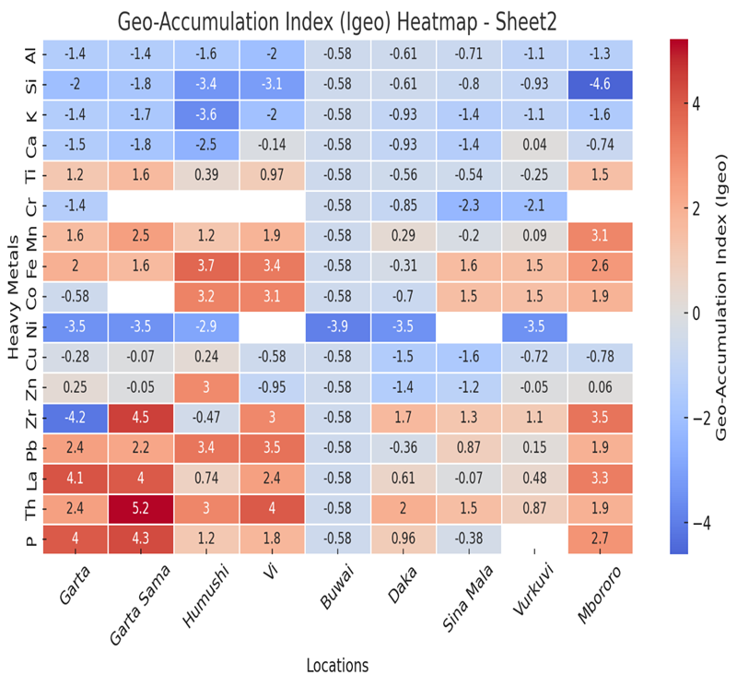
Figure 3: The Geo Accumulation index of the Soil Sample
From figure 3, Pb, La, Th, and P shows high contamination in most locations, Zr in Garta Sama, Vi, Daka, Sina Mala, Vurkuvi, and Mbororo. Mn and Fe in Humushi, Vi, and Mbororo indicate moderate conta mination. While Al, Si, K, Ca, Cr, Ni, and Cu show low contamination, Zn in most locations (except Humushi and Mbororo) also indicates low contamination.
Lead (Pb): Garta (2.43), Garta Sama (2.24), Humushi (3.44), Vi (3.52), and Mbororo (1.92) show high contamination. Lead is a toxic metal that can cause severe health issues, including neurological damage, especially in children. The high levels in these locations suggest potential anthropogenic sources such as mining. Lanthanum (La): Garta (4.13), Garta Sama (4.00), and Mbororo (3.27) shows heavy contamination. Lanthanum is a rare earth element, and its high levels may indicate contamination from industrial processes. Thorium (Th): Garta Sama (5.22), Humushi (3.05), Vi (4.01), and Mbororo (1.92) show heavy contamination. Thorium is a radioactive element, and its high levels pose significant health risks, including increased cancer risk. The contamination could be linked to mining or natural geological processes. Cobalt (Co): Humushi (3.16), Vi (3.07), Sina Mala (1.52), Vurkuvi (1.47), and Mbororo (1.88) show moderate to heavy contamination. Cobalt is essential in small amounts but can be toxic at high levels. The contamination could be linked to local mining activities. Al (Aluminum), Si (Silicon), K (Potassium), Ca (Calcium), Cr (Chromium), Ni (Nickel), Cu (Copper), and Zn (Zinc) shows low or no contamination across most locations. its suggest that these metals are within safe limits and do not pose significant environmental or health risks.
[5], studied heavy metal pollution in soil and found elevated levels of Pb, Ni, and Zn in industrial areas of Lagos and Port Harcourt, which is similar to this study findings. [11], also reported significant Mn and Fe pollution in agricultural lands in northern Nigeria.

Figure 4: Concentration of heavy metals of the soil sample
Figure 4 reveals varying levels of heavy metals across the study sites. Key metals analyzed include chromium (Cr), manganese (Mn), cobalt (Co), nickel (Ni), copper (Cu), zinc (Zn), lead (Pb), and thorium (Th). Among these, manganese recorded the highest concentration, with Mbororo standing out with a value approaching 0.89 ppm. This suggests significant manganese accumulation, likely due to either natural mineralization or its release from mining related processes. Similarly, Garta Sama and Vi also exhibited elevated Mn levels, indicating widespread contamination from artisanal activities. Thorium concentrations were particularly high in Garta Sama, with levels exceeding 0.65 ppm, and were also notably present in Vi and Humushi. This is significant as thorium, a radioactive element, poses both chemical and radiological health risks. While natural background levels of thorium in soil are typically between 0.3 and 0.5 ppm, concentrations in these areas exceed this range, suggesting anthropogenic input possibly from ore processing or exposure to monazite-rich minerals. Lead was also prominent in several locations, especially in Vi, Humushi, and Garta Sama, where levels ranged between 0.2 and 0.3 ppm. Although these values are lower than the lead concentrations reported in severely contaminated areas like Zamfara State, they still indicate environmental contamination. Lead is a neurotoxin and is particularly hazardous to children, even at low concentrations. Chromium, cobalt, nickel, and copper were generally found in low levels but were comparatively higher in Humushi and Vi. Chromium was higher in Humushi, suggesting possible geochemical enrichment or contamination from mining operations. The higher presence of cobalt and nickel also follows a similar pattern, again pointing to mining-induced soil pollution. Zinc concentrations were relatively lower across most sites but were modestly higher in Vi and Humushi, which indicates these two locations are hotspots for multi-metal contamination.
However, thorium presents a different case. The background levels of thorium in uncontaminated soil are generally in the range of 0.3 to 0.5 ppm. The observed concentrations in Garta Sama and Vi exceed this range, indicating a possible radiological risk. This is of concern, because thorium exposure is often overlooked in artisanal mining assessments, yet its radioactive nature necessitates careful monitoring and control. Comparing this finding, it becomes evident that Michika’s soil, while moderately contaminated, is less severely impacted than other artisanal mining regions. For instance, in Bagega, Zamfara State, lead concentrations exceeded 110 ppm, leading to a catastrophic lead poisoning outbreak that claimed many lives. Similarly, a study in Jos, Plateau State by [13], reported chromium and lead concentrations of 0.41 ppm and 0.75 ppm respectively, both higher than those found in Michika. A study in Mayo-Belwa, another part of Adamawa State, revealed manganese and cobalt concentrations of 1.05 ppm and 0.27 ppm respectively [14]. These values closely reflect those found in Michika, indicating that manganese and cobalt contamination is a recurring issue in artisanal mining across the region. Likewise, research from Alkaleri in Bauchi State reported similar heavy metal concentrations, with lead up to 0.35 ppm and zinc around 0.25 ppm, again aligning with findings from Vi and Humushi [15]. The soil and water samples from mining sites were significantly contaminated with Pb, Co, and Cr, exceeding WHO limits. This is consistent with similar findings in Zamfara State [16] and Taraba State [17], where artisanal mining has caused elevated metal concentrations in environmental media.

Figure 5: Concentration of Heavy Metal in Blood Sample of Miners
From figure 5: highest concentration of Pb was found in M2 (27.1 µg/L) while the lowest was in M3 24.6 µg/L. Lead (Pb), the World Health Organization and the U.S. Centers for Disease Control and Prevention (CDC) have set a blood lead level of concern at 10 µg/dL (100 µg/L). The miners' mean lead level of 25.94±1.03 is below the limit, suggesting exposure are within acceptable limits. In 2010, a severe lead poisoning outbreak in Zamfara State resulted in at least 163 deaths, including 111 children. The crisis was linked to artisanal gold mining, with extremely high BLLs reported, far exceeding the value in this study. This emphasizes, the severe risks associated with unregulated mining activities. The study found that levels of nickel (Ni), cadmium (Cd), lead (Pb), and arsenic (As) increased with age, being lowest in the 1–10 years group and highest in the 51–60 years group. While specific mean values were not detailed, the trend indicates bioaccumulation over time. Compared to this study, this suggests that prolonged exposure in northern Nigeria may lead to higher heavy metal concentrations, especially in older populations. Arsenic has the highest value in M3 while the lowest was in M2. Arsenic (As) however has a Mean of 12.54 ±0.49. the value may be due Mining ores, groundwater contamination, inhalation of arsenic-rich dust. WHO recommends less than10 µg/L in blood sample. The miners' levels exceed this, indicating significant exposure and potential health risks. Cadmium has a highest value in M2 and the lowest in M1. Cadmium (Cd) has a Mean value of 3.6±0.158, the values obtain may be due to Mining operations, battery production, contaminated water. WHO set a Safety blood cadmium levels of less than 5 µg/L. The miners' levels are within the limit but still required monitoring due to close value to the standard value. Highest value of Chromium was seen in M2 (6.2 µg/L) while the was seen in M3 (6.9 µg/L). Chromium (Cr) has a Mean, 6.56 ±0.28, the value seen may be as a result of Mining dust, contaminated groundwater, welding fumes. Also, again Nickel (Ni) has a Mean of 8.18 ±0.25, and this maybe as result Mining activities, metal refining, airborne dust. Highest level of manganese was found in M3 (13.2 µg/L) and the lowest in M2 (15.1 µg/L) Manganese (Mn) has a Mean value of 14.36±0.73, the value obtain may be due to Mining, inhalation of dust, contaminated water. WHO Standard for blood levels is less than 10 µg/L for manganese. The miners' levels exceeded this study, suggesting potential neurological risks. Research conducted by [18], examined blood samples from 30 electronic waste scavengers at the Jakande dumpsite, Lagos. The geometric mean blood lead level (BLL) was 11.0 µg/dL (110 µg/L), with a maximum of 24.0 µg/dL (240 µg/L). Manganese (Mn) levels averaged 19.38 µg/dL (193.8 µg/L). These figures are higher than this study BLL of 25.94 µg/L and Mn level of 14.36 µg/L, indicating greater exposure among the e-waste scavengers
More again, [19], assessed heavy metal levels in the blood and urine of 60 children in Owerri, Imo State. The study detected Pb, Cd, Ni, manganese (Mn), and chromium (Cr) in both blood and urine samples, with blood concentrations higher than urine. Notably, maximum blood concentrations exceeded the values specified by the U.S. Academy of Pediatrics. Although Owerri is in southeastern Nigeria, the findings highlight significant exposure risks for children.
Heavy metals enter the human body through inhalation, ingestion, and dermal absorption, accumulating over time and posing serious health risks. Miners are particularly vulnerable due to prolonged exposure to metal-rich dust, contaminated water, and direct contact with ores. The blood serves as a primary indicator of recent exposure, as metals circulate before being stored in organs like the liver, kidneys, and bones. Figure 6, show the concentration of heavy metal in blood sample of miners across the locations. From the above figure Pb ranged from 24.6 to 27.1 µg/L; 4.8 to 5.5 µg/L Al; 11.9 to 13.2 µg/L As; 3.4 to 3.8 µg/L Cd; 6.2 to 6.9 µg/L Cr; 7.9 to 8.5 µg/L Ni; 13.2 to 15. 1 µg/L Mn. From Figure 6, the concentration of zinc ranged from 5100 to 5200 µg/L and copper ranged from 880 to 905 µg/L. the highest level of zinc was in M2 while M3 has the lowest. Copper has the highest level (905 µg/L) in M5 and M2 the lowest. Copper (Cu) has a Mean value 897 ±12.0, Zinc (Zn) has a Mean value of 5200 ±79.05 this may be due to Mining or contaminated water. WHO Standard Safety levels for copper is less 1,200 µg/L; the miners’ levels are within range. Normal blood zinc levels range between 3,500-7,500 µg/L; miners' levels are within this range. Zinc and copper levels are within normal physiological ranges but must be balanced to prevent deficiencies or toxicity.

Figure 6: Concentration of Copper and Zinc in Blood Sample of Miners
Bioaccumulation Factor in the Blood
The Bioaccumulation Factor (BAF) is a measure of how much a heavy metal accumulates in the blood relative to its concentration in the environment (water). A high BAF indicates significant bioaccumulation, which can pose health risks due to the toxic effects of heavy metals. From figure 7: Lead (Pb) has the highest BAF (4610.71), indicating extreme bioaccumulation. This is worrisome because lead is highly toxic and can cause severe health issues, including cancer. Arsenic (As) also show high BAF values 1254, suggesting significant accumulation in the blood. Copper (Cu), and Zinc (Zn) have moderate BAF values (1651.63, and 1449.68, respectively). Chromium (Cr), Nickel (Ni) and Cadmium (Cd) has a relatively lower BAF (145.45, 117.14 and 120), while Aluminum (Al) and Manganese (Mn) have the lowest BAF values (8.36 and 35.9, respectively). Heavy Metal Contamination in Water and Blood Samples in Niger Delta, Nigeria revealed Pb has a High BAF (4000–5000) due to oil spills and industrial pollution. Cu has Moderate BAF (2000–3000) linked to agricultural runoff and waste disposal. As has Extremely high BAF (10000–12000) due to natural geological sources and mining activities [20]. The BAF values for Cu, and Zn in our study are consistent with this study, indicating similar sources of contamination (industrial and mining activities).

Figure 8: Bioaccumulation Factor of Heavy Metal in Blood Sample
Correlation between Blood and Water
As seen in Figure 9: The Correlation Coefficient (r) (0.92), indicates a strong positive correlation, between heavy metal concentrations in blood and water. As heavy metal concentrations in water increase, concentrations in blood also tend to increase. The high correlation (0.92) suggests that the heavy metal concentrations in water are a significant source of exposure for those individuals’ miners whose blood samples were analyzed. This aligns with the concept of bioaccumulation, where metals in the environment (e.g., water and blood) accumulate in biological tissues. The strong correlation highlights the importance of monitoring and controlling heavy metal pollution in water sources. High concentrations of heavy metals in blood, driven by environmental exposure, can lead to serious health issues such as neurological damage, kidney failure, and cancer.

Health Risk Assessment

Figure 9: Average Daily Intake (ADI) across the mining locations
The Average Daily Intake (ADI) of heavy metals in water across various mining locations in Michika Local Government Area, as shown in Figure 9, reveals significant variations in exposure levels among the sampled sites. Among all the locations, Garta and Sina Mala recorded the highest ADI values, approximately 0.25 mg/kg/day and 0.24 mg/kg/day respectively. These values indicate a considerably high level of daily exposure to heavy metals in these areas, likely due to intense artisanal mining activities and the improper disposal of mining waste into surrounding water sources. Moderately ADI values in Daka (0.18 mg/kg/day) and Vurkuvi (0.13 mg/kg/day), suggesting that residents in these communities are also at elevated risk of exposure. Conversely, locations such as Humushi (0.03 mg/kg/day), Buwai (0.03 mg/kg/day), and Vi (0.07 mg/kg/day) had relatively lower ADI values, although still significant enough to warrant attention, especially over long-term exposure. The control site, which ideally should show negligible contamination, recorded an ADI of 0.07 mg/kg/day, indicating possible diffusion of contaminants from adjacent mining zones or background geological sources. When compared with the (WHO) guidelines, the observed ADI values in Garta, Sina Mala, and Daka are substantially higher than the recommended thresholds for heavy metals. For example, WHO's tolerable daily intake (TDI) limits are 0.0036 mg/kg/day for lead, 0.001 mg/kg/day for cadmium, and 0.0021 mg/kg/day for arsenic. The fact that most locations in this study recorded values an order of magnitude higher than these limits suggests a significant risk of both acute and chronic health effects, including neurological disorders, kidney damage, and carcinogenic outcomes, particularly among vulnerable groups like children and pregnant women.

Figure 10: Hazard Quotient (HQ) across the mining locations
The location Garta shows an alarmingly high HQ of over 3.0, followed by Sina Mala at approximately 2.3, and Garta Sama at about 1.9. These values clearly exceed the safety threshold of 1, indicating significant non-carcinogenic health risks for individuals exposed to environmental contaminants most likely heavy metals like lead (Pb), arsenic (As), and cadmium (Cd)—in these locations. Such elevated HQs suggest persistent and intense artisanal mining activities that have led to environmental degradation and accumulation of toxicants. According to [21], similar trends were observed around mining communities in Ghana, where HQs for Pb and As. were reported to be above 1.5, implying serious health implications. Locations such as Control, Humushi, Buwai, and Vi show HQ values well below 1, suggesting relatively safe exposure levels in these areas. The World Health Organization and USEPA consider an HQ >1 as indicative of potential chronic health effects. Furthermore, [22] and [23] have shown that artisanal mining in Nigeria often correlates with elevated HQs due to poor waste management and ore handling practices. These studies reinforce the findings in this graph, confirming that unregulated mining activities contribute significantly to community health risks.

Figure 11: Cancer Risk across the mining Locations
Figure 11, shows that Garta and Garta Sama have the highest cancer risk values, both slightly above 0.0022. Sina Mala also exhibits a notably elevated CR around 0.0016, followed by much lower values in Vurkuvi, Mbororo, Humushi, Vi, Buwai, Daka and Control, all below 0.0002. According to the U.S. Environmental Protection Agency [24] and World Health Organization [25], an acceptable lifetime cancer risk range is typically between 1×10⁻⁶ (one in a million) to 1×10⁻⁴ (one in ten thousand). Any CR value above 1×10⁻⁴ (0.0001) is considered unacceptable and requires immediate remediation actions. The high CR values in Garta and its neighboring sites are likely the result of intensive artisanal mining, where ores are processed without proper safety protocols, leading to widespread contamination of soil, water, and air. Lead and arsenic, commonly associated with gold and other metal ores, are well-documented carcinogens. Chronic exposure to these elements is known to cause lung, skin, bladder, and liver cancers [26], [27].
CONCLUSION
The findings of this study show that artisanal mining in Michika LGA leads to significant environmental contamination and bioaccumulation of heavy metals in miners, posing serious health risks. Both non-carcinogenic and carcinogenic hazards were observed, especially due to high levels of Pb, Co, and Cr in soil, water, and biological samples.
RECOMMENDATIONS
- Government policies must regulate and formalize artisanal mining activities.
- Awareness programs on the dangers of heavy metal exposure.
- Health interventions should include mandatory use of protective gear for miners and routine blood testing for heavy metals, as well as the provision of alternative drinking water sources in high-risk areas like Sina Mala, Garta Sama and Garta.
- The establishment of environmental monitoring systems and strict enforcement of waste disposal regulations.
- For environmental remediation, the use of sediment traps and phytoremediation is recommended to reduce metal runoff.
REFERENCES
- Ogunyele A, Inuyomi S, Oluwajana O, Ogundele L. Heavy metals, radionuclides activity and mineralogy of soil samples from an artisanal gold mining site in Ile-Ife, Nigeria: implications on human and environmental health. Environ Earth Sci. 2021;8(1):21–9.
- Inuyomi S, Alabi O, Fakunle M, Olukotun S, Oladejo O, Ogundele L. Heavy metals concentrations and naturally occurring radionuclides in soils affected by and around a solid waste dumpsite in Osogbo metropolis, Nigeria. Environ Monit Assess. 2021;2(3):193–100.
- Nganje T, Ukpong A, Edet A. Baseline concentration and sources of trace elements in groundwater of Cross River State, Nigeria. Int J Environ Monit Anal. 2014;2(1):1–7.
- Adamu C, Nganje T. Heavy metal contamination of surface soil in relationship to land use patterns: a case study of Benue State, Nigeria. Mater Sci Appl. 2010;1:127–34. https://doi.org/10.4236/MSA.2010.13021
- Obiora SC, Chukwu A, Davies TC. Heavy metal contamination in soils from auto-mechanic workshops in Nigeria.
- Atipo M, Olarinoye O, Awojoyogbe B. Comparative analysis of NORM concentration in mineral soils and tailings from a tin-mine in Nigeria. Environ Earth Sci. 2020;79(16):394.
- Abiy AK, Girma TY, Solomon SS, Yohannes SB. Pollution level of heavy metals and risk implications from the Lower Omo River: East African fresh water in the semiarid region of Southern Ethiopia. J Appl Sci Environ Manage. 2024;28(6).
- Belle G, Fossey A, Esterhuizen L, Moodley R. Contamination of groundwater by potential harmful elements from gold mine tailings and the implications to human health: a case study in Welkom and Virginia, Free State Province, South Africa. Groundw Sustain Dev. 2021;12:100507.
- Hadzi GY, Essumang DK, Kwaku-Adjei JK. Assessment of contamination and health risk of heavy metals in selected water bodies around gold mining areas in Ghana. J Health Pollut. 2018;5(9):86–99.
- Obasi PN, Akudinobi BB. Potential health risk and levels of heavy metals in water resources of lead–zinc mining communities of Abakaliki, southeast Nigeria. Appl Water Sci. 2020;10(7):1–23.
- Adewumi AJ, Laniyan TA. Contamination, ecological, and human health risks of heavy metals in water from a Pb–Zn–F mining area, North Eastern Nigeria. J Water Health. 2023;21(10):1470–88.
- Bello SI, Aminu D, Olawuyi OJ, Afolabi-Balogun NB, Lawal AO, Azeez AH, et al. Antibiotic sensitivity of bacterial and fungal isolates from tomato (Solanum lycopersicum L.) fruit.
- Ayenimo J, Mamba B, Yusuff A, Adekunle A, Odukudu F. Safety evaluation of heavy metals exposure from consumer products. Int J Consum Stud. 2014;38:25–34. https://doi.org/10.1111/IJCS.12061
- Kolo M, Joseph S, Olarinoye O, Oduh I. Evaluation of radioactivity concentration of some selected mineral rocks from Mayo-Belwa Local Government Area of Adamawa State, Nigeria. Dutse J Pure Appl Sci.
- Ezekiel OA, Mohammed SC, Stephen U. Assessment of heavy metals contamination of soil and water around abandoned Pb-Zn mines in Yelu, Alkaleri Local Government Area of Bauchi State, Nigeria. Int Res J Public Environ Health. 2017;4(5):72–7.
- Baba Y, Watanabe M, Yoshida N, Baba H. Neoadjuvant treatment for esophageal squamous cell carcinoma. World J Gastrointest Oncol. 2014;6(5):121.
- Usman SI, Gambo M, Dimas MM. Human health risk assessment of heavy metals in mining areas of Taraba State. Niger J Basic Appl Sci. 2022;30(1):89–97.
- Popoola O, Kehinde A, Ogunleye V, Adewusi OJ, Toy T, Mogeni OD, et al. Bacteremia among febrile patients attending selected healthcare facilities in Ibadan, Nigeria. Clin Infect Dis. 2019;69(Suppl 6):S466–73.
- Verla A, NgoziVerla E, MedoAjero C, ChiomaLele K, Stellamarris N, Enyoh C. Biomonitoring of heavy metals in blood and urine of African children.
- Ohiagu FO, Lele KC, Chikezie PC, Verla AW, Enyoh CE. Pollution profile and ecological risk assessment of heavy metals from dumpsites in Onne, Rivers State, Nigeria. Chem Afr. 2021;4(1):207–16.
- Bortey-Sam N, Nakayama SMM, Ikenaka Y. Assessment of heavy metal pollution and health risk in urban soils around a gold mine in Ghana. Environ Monit Assess. 2015;187(1):1–11.
- Awofolu O. A survey of trace metals in vegetation, soil and lower animal along some selected major roads in metropolitan city of Lagos. Environ Monit Assess. 2005;105:431–47.
- Nganje TN, Udoinyang EP, Ukpong AJ. Evaluation of heavy metals and natural radioactivity in soil within and around mechanized and artisanal gold mines in southern Nigeria. Afr J Environ Sci Technol. 2010;4(3):100–6.
- United States Environmental Protection Agency (USEPA). Exposure Factors Handbook: 2011 Edition. Washington DC: U.S. Environmental Protection Agency; 2011.
- World Health Organization (WHO). Guidelines for Drinking-water Quality: Fourth Edition Incorporating the First Addendum. Geneva: WHO; 2017.
- Jarup L. Hazards of heavy metal contamination. Br Med Bull. 2003;68(1):167–82.
- Agency for Toxic Substances and Disease Registry (ATSDR). Toxicological Profile for Arsenic. U.S. Department of Health and Human Services; 2007.

Maitera O. N., Yusuf E.Y., Buba One M. and Joshua G. A. (2025). Bioaccumulation of Heavy Metals in Artisanal Miners and Associated Health Risk Assessment in Michika Local Government Area, Adamawa State, Nigeria. IDOSR JOURNAL OF SCIENCE AND TECHNOLOGY 11(2):10-20. https://doi.org/10.59298/IDOSR/JST/25/112.102000

